Projekt Munka tesztfázis

Topológia:

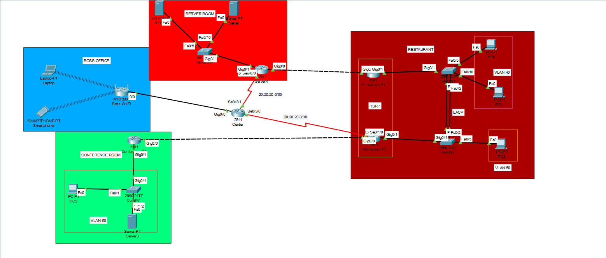

IP tábla:

|  |  |  |  |  |
| --- | --- | --- | --- | --- |
| Eszköz | Interface | IP | Subnet | Gateway |
| Center | Gig/0/0  Se0/3/0  Se0/3/1 |  |  |  |
| Restaurant R1 | Gig0/0  Gig0/1 |  |  |  |
| Restaurant R2 | Gig0/0  Gig0/1  Se0/1/0 |  |  |  |
| ServerR | Gig0/0  Gig0/1  Se0/0/0 |  |  |  |
| Conference R1 | Gig0/0  Gig0/1 |  |  |  |
| Boss Wi-Fi |  |  |  |  |
| ReSW1 | Fa0/1  Fa0/2  Fa0/5  Fa0/10 |  |  |  |
| ReSW2 | Fa0/1  Fa0/2  Fa0/5 |  |  |  |
| ServerSW |  |  |  |  |
| ConSW |  |  |  |  |
| PC0 |  |  |  |  |
| PC1 |  |  |  |  |
| PC2 |  |  |  |  |
| HTTP |  |  |  |  |
| Server |  |  |  |  |
| Printer |  |  |  |  |
| Laptop |  |  |  |  |
| Smartphone |  |  |  |  |
| Printer1 |  |  |  |  |
| PC3 |  |  |  |  |

Vlan tábla: